ONE POSITION AVAILABLE FOR ERASMUS+ INTERNSHIP
/ At the International OFFICE Blekinge Institute of Technology

Position title | Student Internship/ Erasmus + Student work placement
Duration | 6 months (from 15 August 2016 to 13 January 2017)
Location | Blekinge Tekniska Högskola, 371 79 Karlskrona
Working hours | 08:00 - 16:30, 30 min lunch break, longer working hours in special occasions
Payment | No salary : the student is expected to have an Erasmus + scholarship or other financial support from His / her home university
Tasks of the trainee: | Participate in the daily work of the International Office for 8 hours per day (regular Swedish working hours).  Help out the International Coordinators with various tasks.  Participate in small scale trainings regarding the programs and databases you will use: Lotus Notes, Ladok, Outlook  The intern will have the following work tasks during the internship;  Project “International Day 2016”  The intern will have the role as coordinator, which means responsible for planning, organizing and administrating an International Day at BTH. This day will take place on November 2016 . This is a big project and the intern will mainly focus on this project. Some of the work tasks;  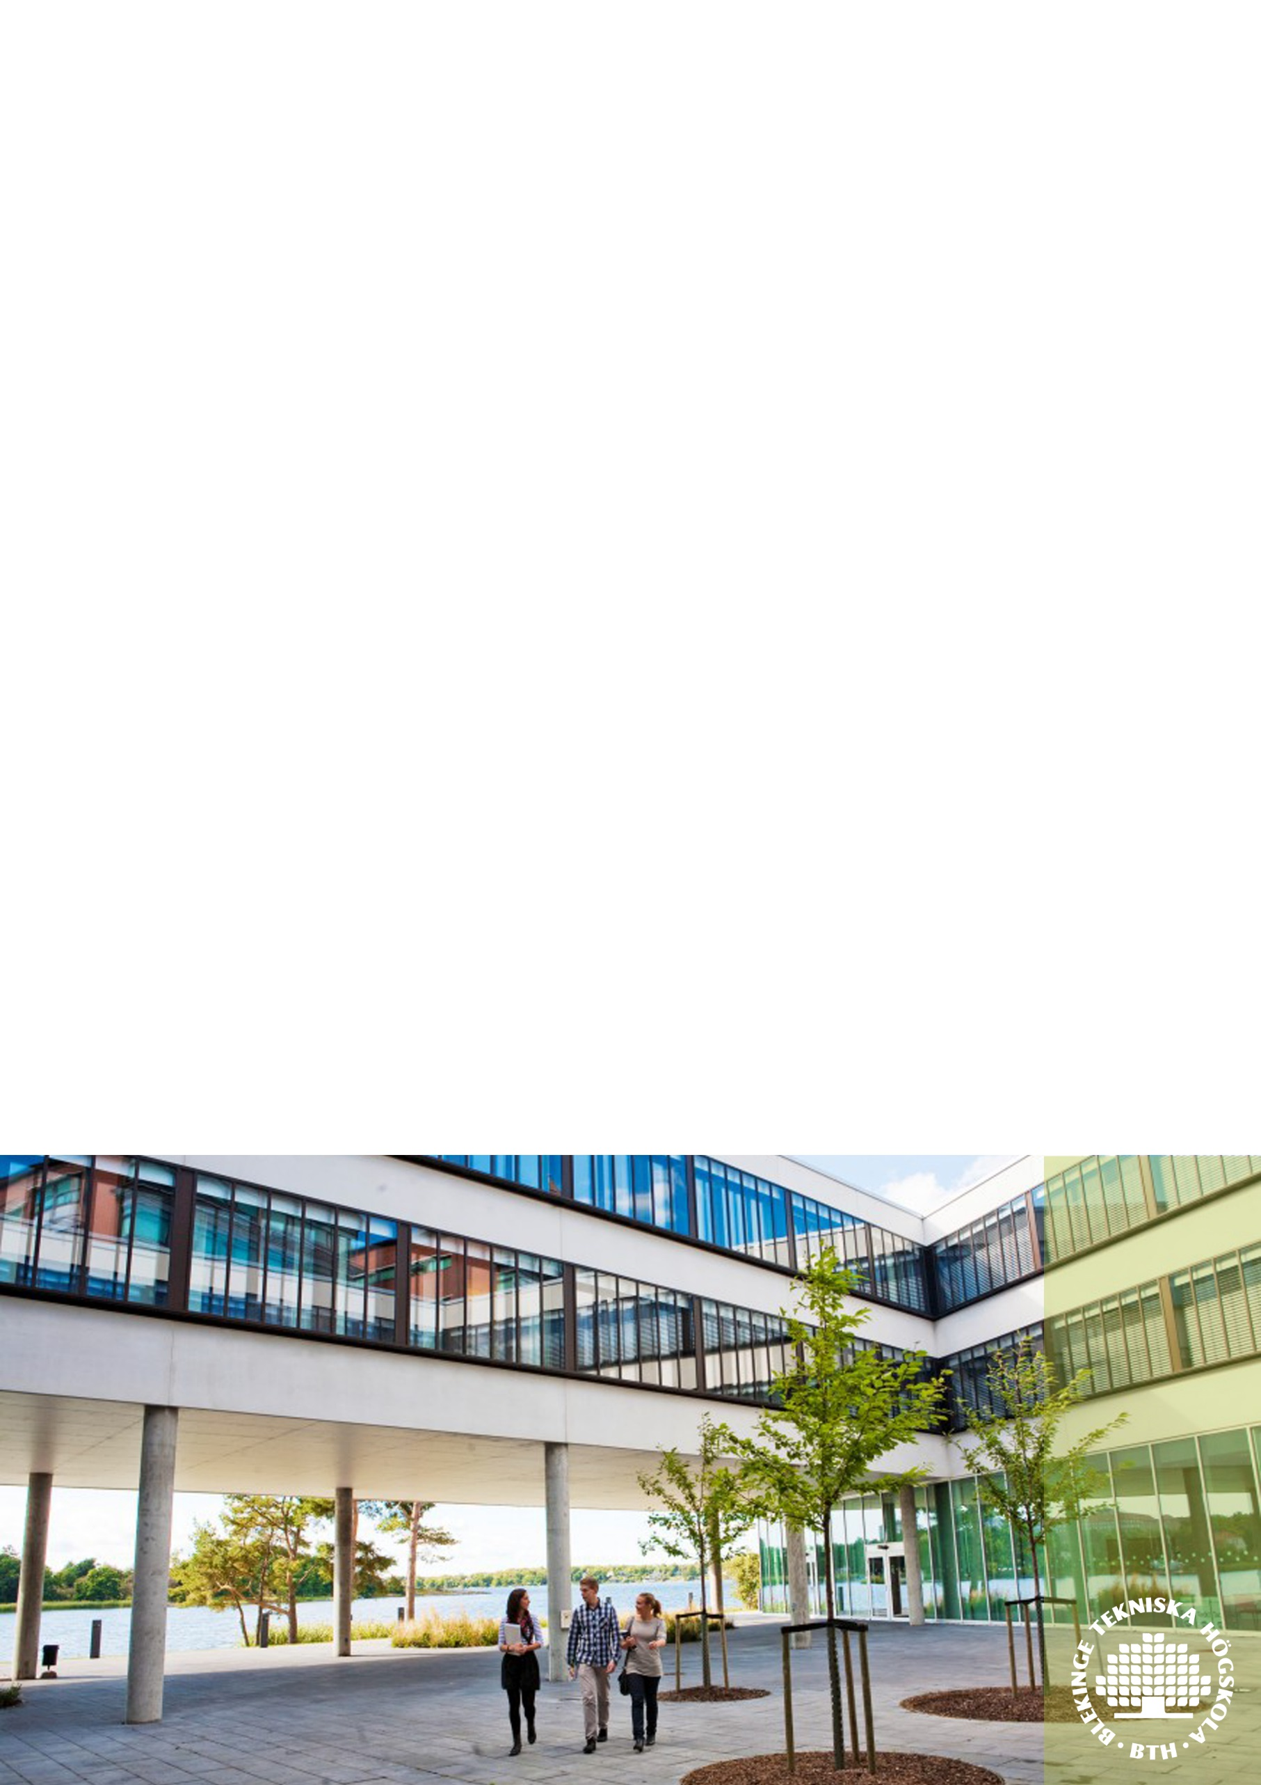  - Project organization and project plan  - Information and marketing  - Budget and purchase  - Collaboration with students  General administrative work tasks at International Office  Other work tasks at International Office
Background and requirements of applicants: | Applicants from different academic fields and backgrounds are welcome to apply for the internship. The applicant has to have completed a two years of successful studies at university level at the start of the placement. Being familiar with the Erasmus+ Mobility Exchange Programme represents an advantage for the application. High English communication skills, verbal and in writing, are required. Both Swedish language skills and experience within a student union will be also merited. An application including support documents from the home university, CV and a motivation letter should be sent to in.exchange@bth.se .
Application procedure: | Send your CV togheder with a cover letter describing why you would like to take an internship at BTH  Applications should be sent by e-mail to in.exchange@bth.se  In case of any further questions please do not hesitate to get in touch and send your enquiries to in.exchange@bth.se

